+Unit 5 - Properties of Figures

Properties of Triangles

Regular polygon - a closed figure with three or more straight sides and equal side and angle measurements. Equilateral triangles, Rectangles, Squares are all regular polygons.



|  |  |  |
| --- | --- | --- |
| Type of Triangle | Diagram | Properties |
| Equilateral | http://mathworld.wolfram.com/images/eps-gif/EquilateralTriangle_1000.gif | * All three angles are equal/ have the same measure * All three sides are equal/ have the same length |
| Isosceles | http://mathworld.wolfram.com/images/eps-gif/IsoscelesRightTriangle_1000.gif | * Two of the three angles are equal/ have the same measure * Two of the three sides are equal/ have the same length |
| Scalene | http://mathworld.wolfram.com/images/eps-gif/ScaleneTriangles_1001.gif | * All three angles in the triangle are different * All three side lengths in the triangle are different |

* Trick to remember the triangle names:

1. Put the three triangle names in alphabetical order.
2. Then apply the 3-2-1 rule:
   1. The first triangle (equilateral) has 3 equal sides.
   2. The second (isosceles) has 2 equal sides.
   3. The third (scalene) has 1, or no equal sides.

Other Properties of Triangles

|  |  |  |
| --- | --- | --- |
| Property | Diagram | Explanation |
| The angle property of triangles | http://dj1hlxw0wr920.cloudfront.net/userfiles/wyzfiles/f0516fa1-669b-441d-9f11-a33907a2a0b0.gif | * The sum of the three angles in a triangle must equal 180° |
| Acute Angles | http://00.edu-cdn.com/files/static/learningexpressllc/9781576856239/GEOMETRY_22.GIF | * Angles that are less than 90° * All three angles in this triangle are acute |
| Obtuse Angles | http://00.edu-cdn.com/files/static/learningexpressllc/9781576856604/Classifying_Triangles_03.gif | * Angles that are more than 90° but less than 180° * One angle in this triangle is obtuse, the others are acute |

Angle Properties of Quadrilaterals 5-1 March 2

|  |  |  |
| --- | --- | --- |
| Type | Diagram | Properties |
| Rectangle |  | * Has four right angles * The sum of all the angles is 360° |
| Isosceles Trapezoid |  | * Two Equal sides * The two angles (represented by dots are equal) * The sum of all the angles is 360° |
| Square |  | * Has four right angles * All four side are equal in length * The sum of all the angles is 360° |
| Parallelogram |  | * Opposite angles in a parallelogram are equal * Opposite sides are parallel to one another * The sum of all the angles is 360° |

To discover the relationship between the sum of the interior angles and the number of sides in a regular polygon, we can separate each polygon into triangles by drawing diagonals.

The following table looks at the sum of the interior angles as we go from one polygon to the next.

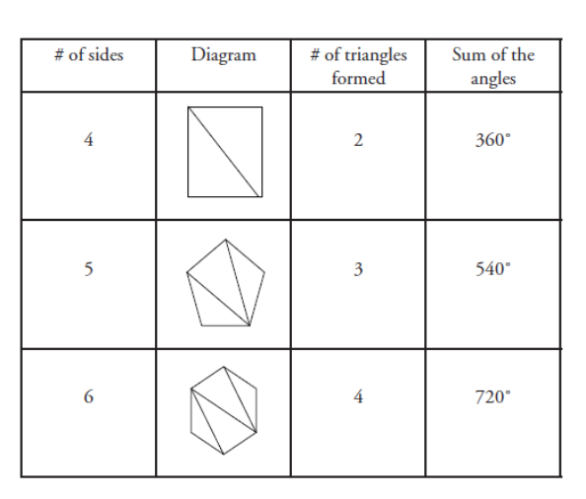

What do we see about the number of triangles formed as the number of sides in the regular polygon increase?

**Each time we add a side to our polygon we can form one more triangle using diagonals, but the number of triangles formed is always two less than the number of sides.**

What do we see about the sum of the angles in our polygon as the number of triangles increases?

**For each new triangle we can form we add 180° to the sum of the angles**

**So for each new side added to a regular polygon we add 180° to the sum of the angles in that polygon.**

**Formulas for the angles in a regular polygon**

|  |  |
| --- | --- |
| Sum of the angles | Measure of each angle |
| $$S=180(n-2)$$ Where S is the sum of the angles, and n represents the number of sides in the polygon. | $$M=\frac{180(n-2)}{n}$$ Where M is the measure of each angle, and n represents the number of sides in the polygon. |

Ex: Determine the sum of the interior angles, and the measure of the interior angles in a regular hexagon

A Hexagon has six sides, so in our equation, n = 6

|  |  |
| --- | --- |
| $S=180°\left(n-2\right)$ $$S=180°\left(6-2\right)$$ $$S=180°(4)$$ $$S=720°$$ The sum of the angles is 720° | $$M=\frac{180°(n-2)}{n}$$ $$M=\frac{180°(6-2)}{6}$$ $$M=\frac{180°(4)}{6}$$ $$M=\frac{720°}{6}=120°$$ The measure of each angle is 120° |

*The measure of the angle formula does not work for all polygons that have been explored. It cannot be applied for the irregular polygons explored (i.e., triangles, scalene triangles, parallelograms and isosceles trapezoids).

**This is because the measure of an angle formula implies that the angles of the polygon are all equal, which also means that the side lengths are equal.**

**This formula only works for Regular Polygons**

Ex: Determine the measure of each angle in an isosceles triangle,

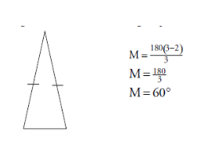

This results in each angle measuring 60°. This makes the triangle equilateral rather than isosceles.

**Tessellations**

**Tessellate -** to cover an area using the repetition of geometric shapes, with no overlaps and no gaps.

**When the interior angles where the vertices meet total exactly 360°, it means the polygon can tessellate an area.**

Ex: Jeff is a tile setter. His clients want to use tiles in the shape of a regular hexagon or a regular pentagon for their bathroom floor. Which shape will tessellatethe area?

Measure the interior angles where the vertices of the hexagons meet.

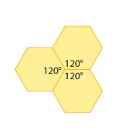

Each of the interior angles is 120°. The sum of the three angles is 360°. Therefore, a regular hexagon can be used to tile the floor.

Measure the interior angles where the vertices of the pentagon meet.

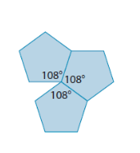

Each of the interior angles is 108°. The sum of three angles is 324°. The sum of four angles is 432°. Therefore, a regular pentagon cannot be used to tile the floor.

https://www.youtube.com/watch?v=7GiKeeWSf4s

Which figures NATURALLY tessellate?

1)

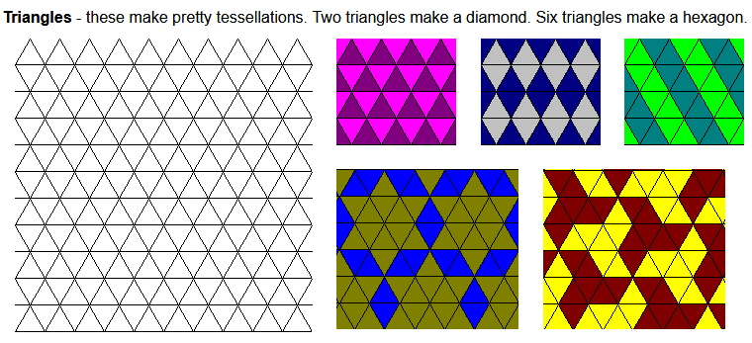

2) 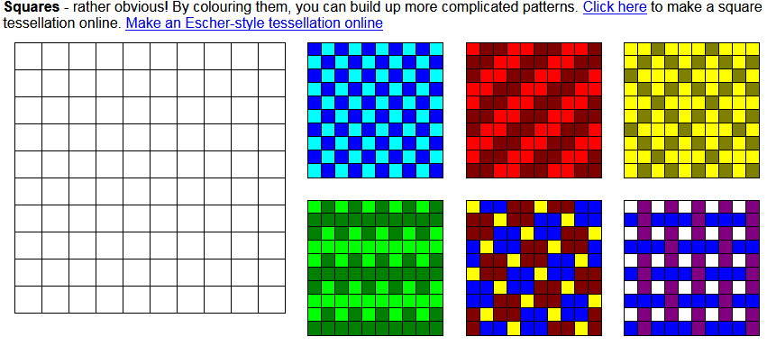

3)

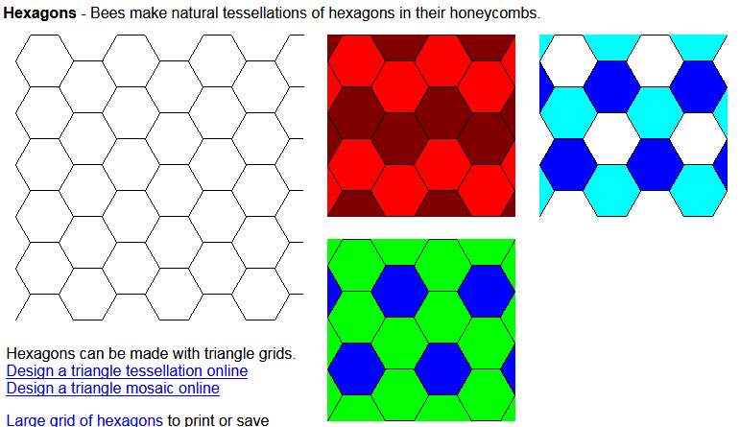

**All triangles, squares and regular hexagons will tessellate. This is because at any point where vertices meet, the sum of the angles is 360°.**

**5- 2 Side Length Properties of Triangles**







* The side opposite (arrows) the largest angle is the longest side.
* The side opposite (arrows) the smallest angle is the smallest side.
* **The sum of any two sides must be greater than the length of the third side.**
* **10 + 11 > 15 Y**



* **10+15 > 11 y**
* **11+15 > 10 y**

Ex: Cathy is a landscaper. She is creating a design for a client’s backyard.

**a)** The client gives Cathy the measurements for the existing triangular garden. How does Cathy know the measurements are incorrect?

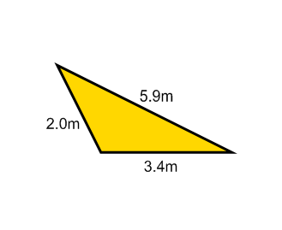

not possible---- to draw a triangle with the provided measurements.

The sum of the lengths of any two sides of a triangle must be greater than the length of the third side.

2.0 + 3.4 > 5.9 ? yes or no therefore triangle is or is NOT possible

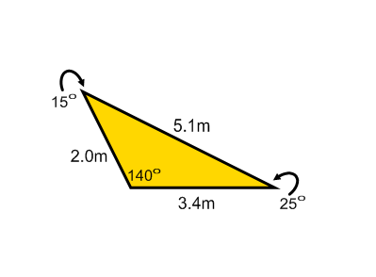**b)** Cathy asks the client for correct measurements, including angle measures. How does Cathy know that the client made another error?

Cathy knows the client’s drawing is incorrect because the client labelled the angle opposite the smallest side with the second smallest angle.

Ex: Are these triangle measures possible?

|  |  |
| --- | --- |
| A)  These triangle lengths are not possible, because the sum of any two sides of the triangle is NOT greater than the length of the third side.  So the two sides 7in +7in = 14in must be greater than the third side, 16in. Since this is not true, the triangle cannot be made. | B)  These triangle lengths are possible, because the sum of any two sides of the triangle is greater than the length of the third side.  Pg. 244-245 #’s 1-6 |



5-2/5-3 Side Length Properties of Quadrilaterals



|  |  |  |
| --- | --- | --- |
| Type | Diagram | Properties |
| Rectangle | http://i.stack.imgur.com/v7CDE.png | * Opposite sides are parallel * Diagonals of a rectangle (opposite sides are parallel) equal * tessellates |
| Isosceles Trapezoid | http://education-portal.com/cimages/multimages/16/Isosceles_trapezoid.jpg | * Diagonals are equal to one another. * The sum of the angles where the diagonals of a quadrilateral intersect will be 360° * Tessellation |
| Square |  | * Diagonals of a square are equal. * Diagonals will intersect to form right angles (90°) * Tessellates |
| Parallelogram | http://upload.wikimedia.org/wikipedia/commons/a/a8/Parallelogram.jpg | * Diagonals are not equal, the largest diagonal is opposite the largest angle  * Opposite angles are supplementary (sum of 180 degrees) |



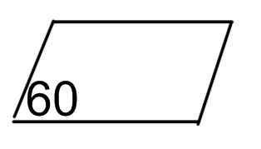



**The diagonals of all quadrilaterals will intersect at the midpoint of the diagonals.**



**The sum of the angles where the diagonals of a quadrilateral intersect will be 360° [Tessellation]**

Ex: Determine the missing measurements.

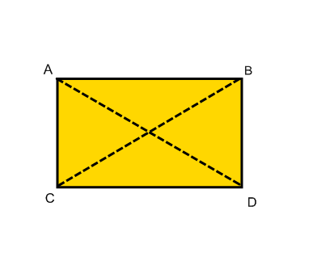



|  |  |
| --- | --- |
| AB = 8 in | AD = 10in |
| AC = 6 in | BC = ? |
| CD = ? | BD = ? |



Side AB and Side CD are opposite one another, so they must be equal in length, CD = AB = 8in

Side AC and Side BD are opposite one another, so they must be equal in length,

AC = BD = 6in

Both diagonals in a rectangle are the same length, so Line AD = Line BC, so

Line BC = 10 in

Ex: Determine the missing measurements.

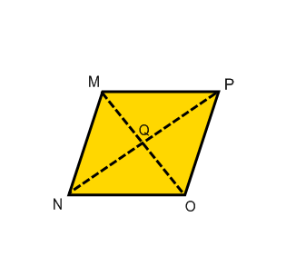



|  |  |
| --- | --- |
| MQ = 7 cm | QN= 9cm |
| MN = 11 cm | QO = ? |
| MO = ? | PO = ? |
| PQ = ? |  |



Line MO is cut exactly in half at point Q, so if line MQ is 7cm, then line QO = 7 cm.

Line MO = Line MQ + Line QO = 7 cm +7 cm = 14cm

Line PO is opposite line MN, so they must be equal to one another. PO = MN = 11cm

Line PQ is equal to Line QN because Line PN is cut exactly in half at point Q, so if line QN is 9cm, then line PQ = 9 cm.



Ex: Determine the missing measurements.



|  |  |
| --- | --- |
| SR = 7.5m | PQ = ? |
| Angle PTS = 110° | Angle QTR = ? |
| Angle QTR +Angle RTS + Angle PTS + angle PTQ = ? | |

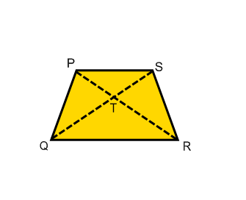



Side SR and Side PQ are opposite one another, so they must be equal to one another. Side SR =Side PQ = 7.5m

Angle PTS is opposite Angle QTR where our two diagonals intersect; this means they must be equal to one another. Angle PTS = Angle QTR = 110°

Where the two diagonals intersect the total sum of the angles must equal 360°. So, Angle QTR +Angle RTS + Angle PTS + angle PTQ = 360°

Ex: A local contractor was hired to build a shed 6 m wide by 8 m long. The four walls of the shed did not look even (plumb) to the homeowner. How could the homeowner check that the walls were “square”?



* The easiest way to see if the walls in a room are square is to measure the diagonals in the room. If the diagonals are equal then the room is square, if the diagonals are not the same length the room is not square

Ex: How can you locate the center of a room?

* The easiest way to locate the center of a room is to make two lines going to opposite corners. Where the two lines intersect is the center of the room.

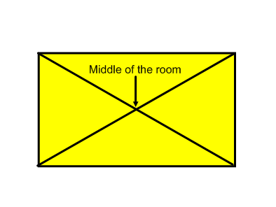



**5-3 Lines of Symmetry**

|  |  |
| --- | --- |
| **Line of symmetry:** a line that dividesa figure into two identical halves sometimes called a **line of reflection** or **axis of**  **symmetry** |  |

**The more lines of symmetry a figure has, the more symmetric the figure is!**

Ex: Jerome is building an inlaid tabletop. He knows that symmetry in designs is pleasing to the eye. Which shape shown will provide the greater symmetry, the rectangle or the parallelogram?

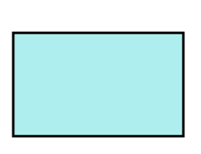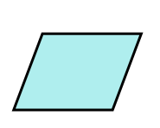

|  |  |
| --- | --- |
| **Rectangle:**  A rectangle has two sets of two equal side lengths. It also has four angles that are equal in measure.  **A rectangle has two lines of symmetry.** |  |
| **Parallelogram:**  A parallelogram is a four-sided polygon with opposite sides that are parallel and opposite angles that are equal in measure.  **The parallelogram shown has no lines of symmetry.** |  |

**A rectangle will provide the most symmetry for Jerome’s tabletop design.**

Ex: Which type of triangle has the greatest symmetry?

|  |  |
| --- | --- |
| **Scalene triangle:**  Since a scalene triangle has no equal side lengths and no equal angle measures, **there are no lines of symmetry.** |  |
| **Isosceles triangle:**  Since an isosceles triangle has two equal side lengths and two equal angle measures, **there is one line of symmetry.** |  |
| **Equilateral triangle:**  Since an equilateral triangle has three equal side lengths and three equal angle measures, **there are three lines of symmetry.** |  |

**An equilateral triangle has the greatest symmetry, because it has the most lines of symmetry.**

**Lines of Symmetry in different figures**

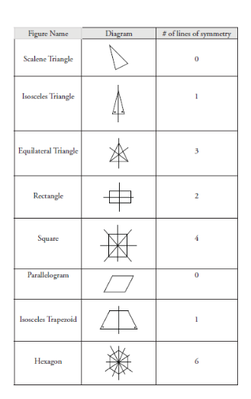

**\*The number of lines of symmetry in a regular polygon (figures that have equal angles at each corner, and equal side lengths) is equal to the number of vertices.**



**Formulas I need to know from the Unit 5**

**Properties of Figures and Polygons**



1. **All angles in a triangle have a sum of 180 degrees**



1. **The interior angle sum of any regular polygon is  where n is the number of sides**
2. **Each angle in the regular polygon has a measure of  where n is the number of sides**
3. **Types of triangles (scalene, isosceles, equilateral)**
4. **When triangles are possible? (i) two sides must always be greater than the third remaining side (ii) the largest side must be opposite the largest angle etc.)**
5. **Types of regular polygons: equilateral triangle, square, pentagon, hexagon**



1. **Types of Angles in a polygon (obtuse, right, acute)**
2. **Side lengths and diagonals properties of Polygon (Page 241)**
3. **Lines of symmetry**
4. **How many lines of symmetry a polygon has. (See handout)**

**Assignment: When the work is completed.**

**Page 230 1,2,5,6,7,8,9, 10**

**Page 235 1,2,3,4,**

**Page 241 1, 3, 7**

**Page 245 1,2,3, 6**

**Page 249 6**

**Page 251 1,2,4, 6**

**Page 255 1,2,**

**March 19**

**Page 256, 6, Page 257 1, 2, 3**

**Skill Check (Review for the Unit!)**

**Page 258 1,2**

**Page 259 4,5,6,8**

**Page 259 6,8**