Mathematics 3200 Unit 5: Trigonometric Functions and Graphs

Name:_________________________ /25

**Part A: Selected Response:** Place the letter of the correct response in the space provided.  
 (13 marks)

1. What is the period of ?

(A)  (B) 

(C)  (D) 

2. What is the range of the function ?

(A) 

(B) 

(C) 

(D) 

3. What are the transformation of the graph ?

(A) horizontal stretch by a factor of  and a horizontal shift of units right

(B) horizontal stretch by a factor of  and a horizontal shift of  units right

(C) horizontal stretch by a factor of  and a horizontal shift of  units right

(D) horizontal stretch by a factor of  and a horizontal shift of  units right

4. Solve for x:  where 

(A)  (B) 

(C)  (D) 

5. If the point lies on the graph of , what is the value of *a*?

(A)  (B) 

(C) 2 (D) 

6. Which graph has the same *y*-intercept as?

(A)  (B) 

(C)  (D) 

7. The range of a trigonometric function of the form is . What is the value of d?

(A) 1 (B) 3

(C) 5 (D) 8

8. What is the maximum value of ?

(A) -7 (B) -3

(C) 3 (D) 7

9. The partial graph of a trigonometric function is shown. The graph has a maximum value at and a minimum value at .

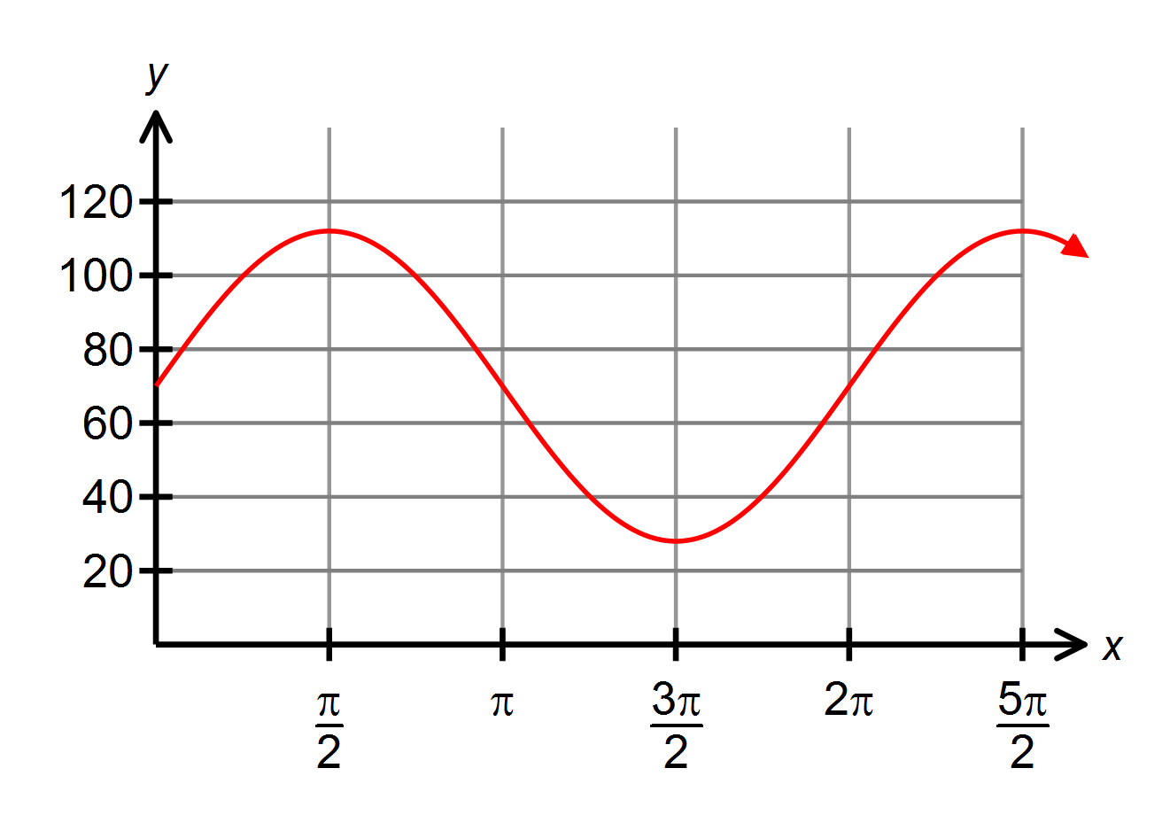

(A) 

(B) 

(C) 

(D) 

10. What is the domain of ?

(A) 

(B) 

(C) 

(D) 

11. A Ferris wheel with a radius of 6m rotates once every 30 seconds. Passengers get on board at a point 1m above the ground at the bottom of the Ferris wheel. Which function models this situation?

(A) 

(B) 

(C) 

(D) 

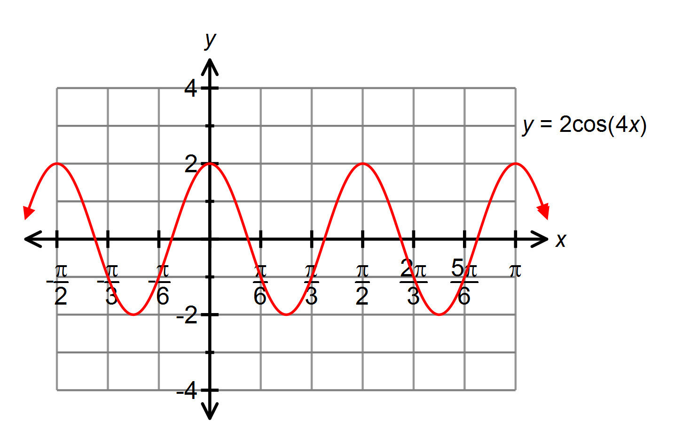12. Given the graph below, what is the solution for  where ?

(A) 

(B) 

(C) 

(D) 

13. Write the equation of the sine function if the amplitude is 3 and the period is ?

(A)  (B)   
(C)  (D) **Part B: Constructed Response:** Show workings to all problems.

/4 14. Write the equation for the graph shown in the form and in the form .

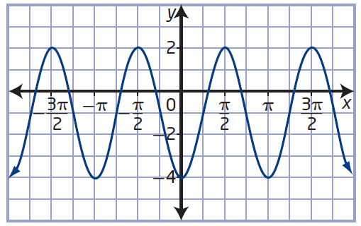

Sine graph: _____________________________

Cosine graph: _____________________________

/4 15. Determine all solutions, in radian measure, for the equation 

Solutions:________________________________

/4 16. Sketch the graph of the function. State the domain range.

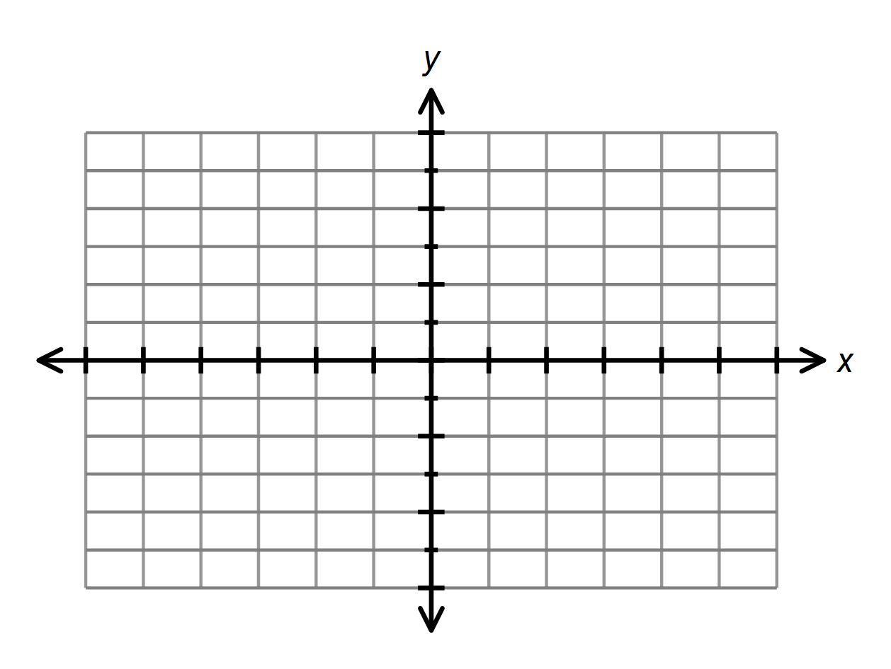

Domain: ____________________

Range: ____________________