Chapter 6 Test

For #1 to #5, select the best answer.
1. Point P(3,3) is reflected over the y-axis and translated 3 units down. What are the coordinates of the new point?
A (0, –3) B (3, 0)
C (–3, 0) D (–3, 3)
2. Reflect the circle over the x-axis. Then, reflect it over the y-axis. Where is the centre of the
final image?
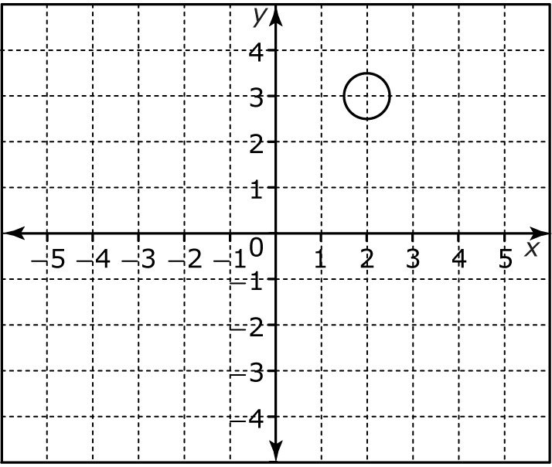
A (2, –3) B (–2, 3)
C (2, –2) D (–2, –3)
3. A line begins at (0, 0) and ends at (5, 0). When the line is rotated 180°, where is its endpoint?
A (–5, 0) B (0, –5)
C (5, 0) D (0, 5)
4. Rotate the square 90° clockwise about the origin. What are the coordinates of the corners of
the image?
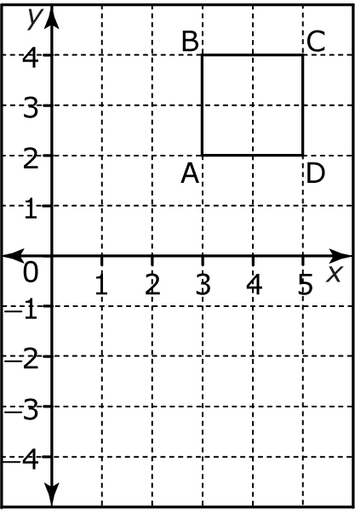
A A′(–2, 3), B′(–4, 3),
C′(–4, 5), D′(–2, 5)
B A′(2, –3), B′(4, –3),
C′(4, –5), D′(2, –5)
C A′(–3, –2), B′(–3, –4),
C′(–5, –4), D′(–5, –2)
D A′(2, –3), B′(4, 3),
C′(4, –5), D′(2, 5)
5. The image has undergone a transformation. Which is the best description of the transformation?
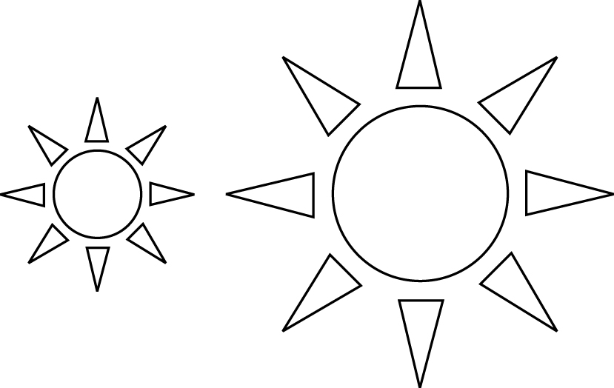
A rotation B dilation
C reflection D translation
6. Describe the transformation(s) used to transform the original
in Quadrant I to the image in Quadrant III.
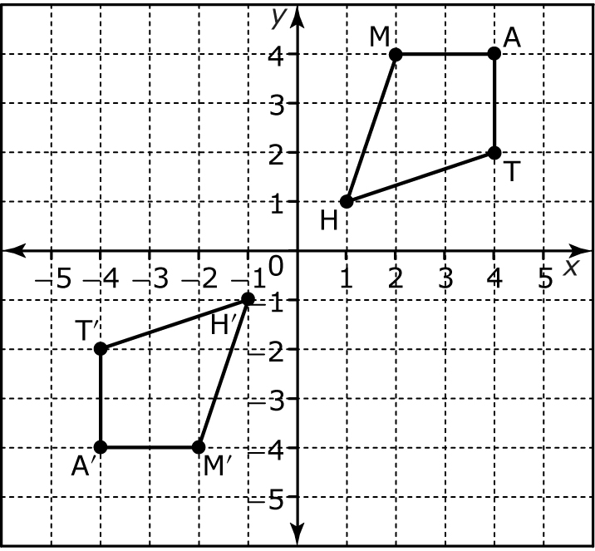
7. Label each of the transformations with one of the following terms: translation, rotation, dilation, reflection.
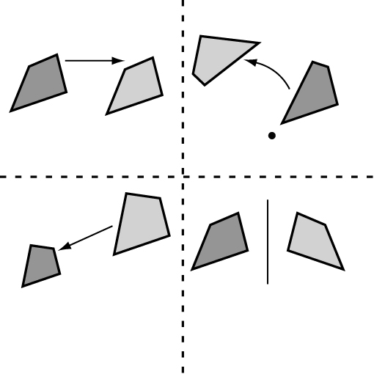
8. Which two transformations
were used to create the
pattern?
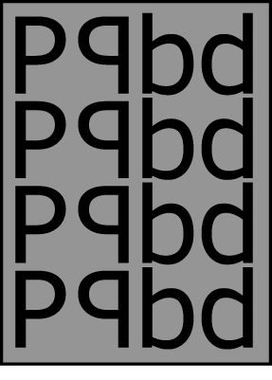
9. An NHL hockey rink has a trapezoid shape behind each goal. Describe two ways of transforming one trapezoid image to the other.
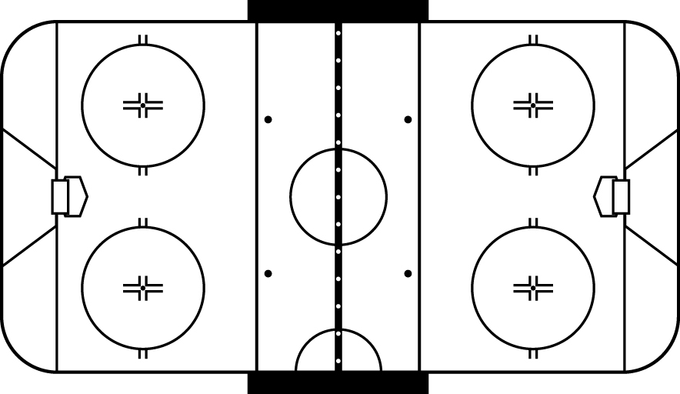
10. Perform the following transformations, in order,
using the diagram.
• translate the shape 2 right and 3 up
• rotate 180° about the origin
• reflect over line r


