Section 6.3 Extra Practice

1. Which of these transformations represent a reflection?
a)
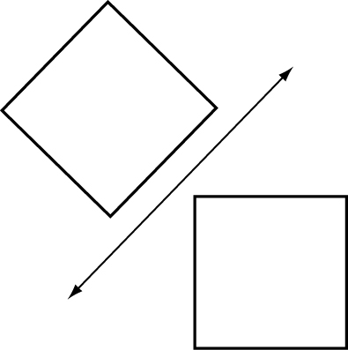
b)
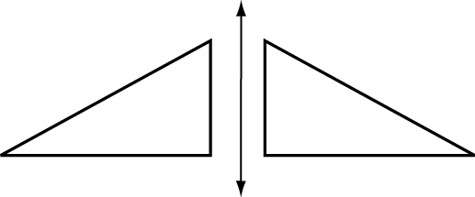
c)
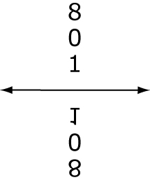
2. Reflect each shape.
a)
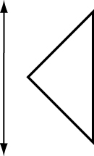
b)
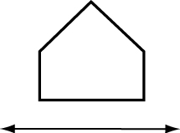
3. Reflect each figure over the line of reflection.
a)
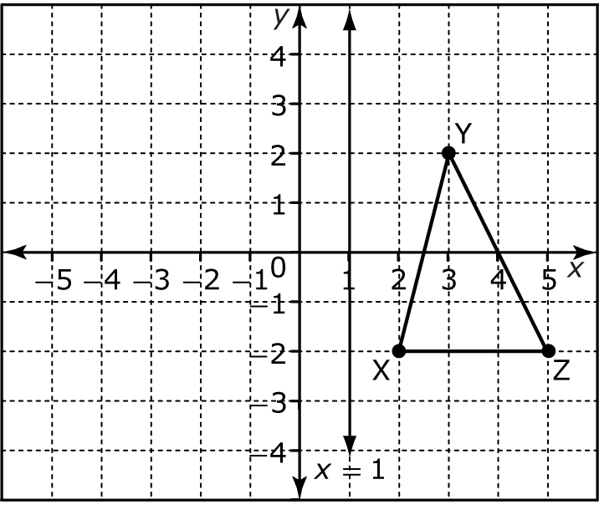
b)
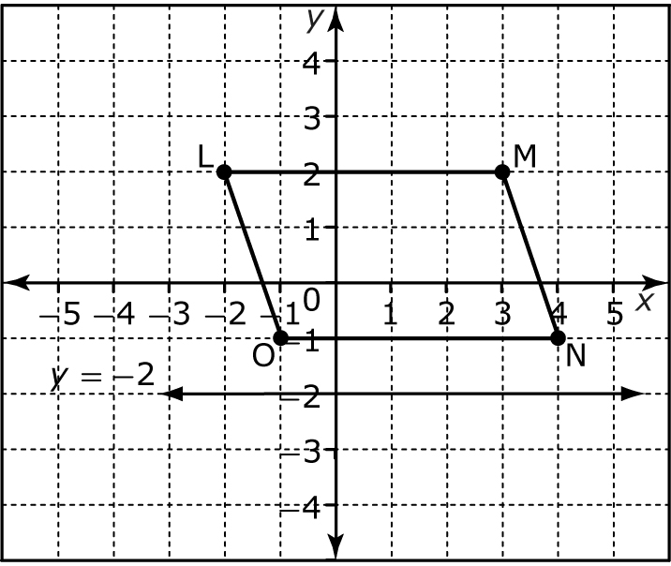
4. Draw a reflection of your phone number and check that it reads properly in a mirror.
5. Describe the transformation used to create each pattern.
a) b)
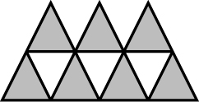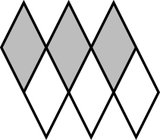
6. a) Draw a line of reflection at
x = 2. Then, reflect the rectangle over it.
b) Translate the reflected image 4 units down.
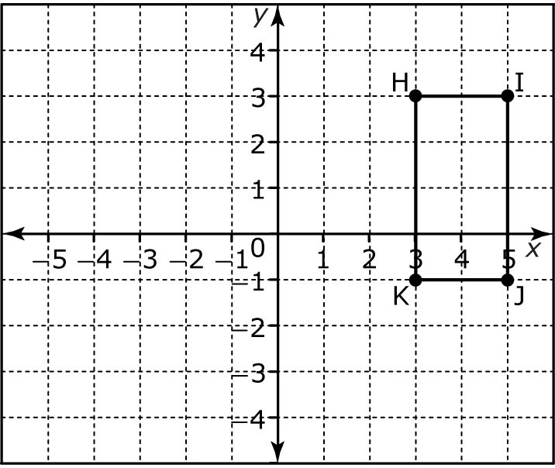
7. a) Draw a line of reflection at
x = –1. Then, reflect the triangle over it.
b) Translate the reflected image 5 units up.
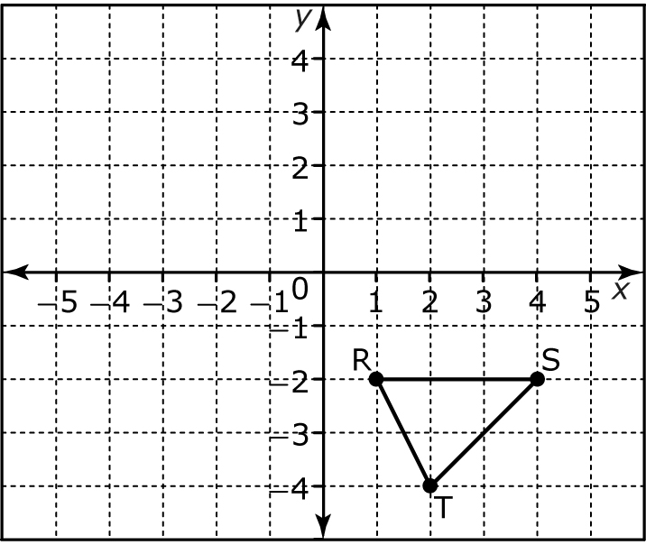
8. Use the tiles to create a pattern that covers a 6 by 6 grid.
a) 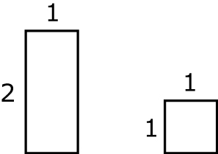
b)


